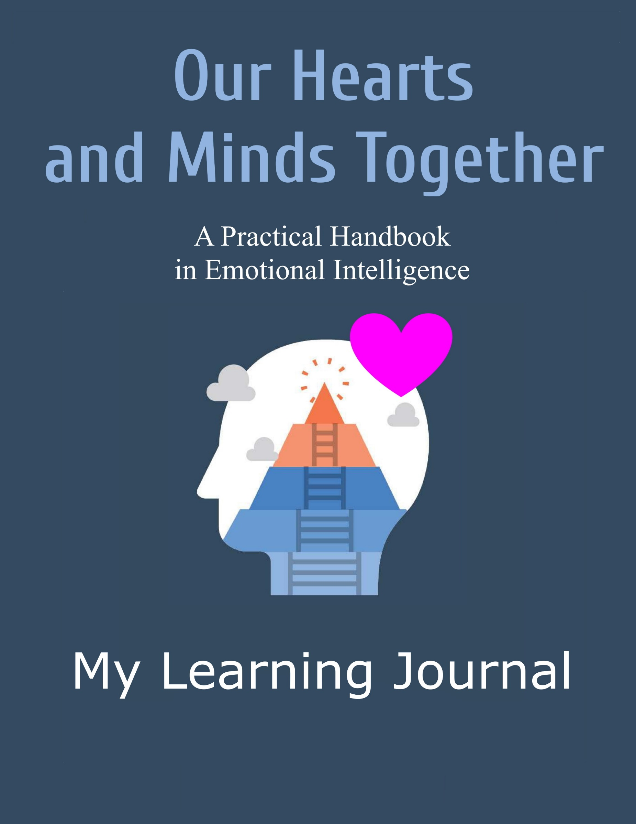

Emotional Intelligence
Learning Journal

Name: ________________

Start date: ____________

This is your journal where you record your observations, experiences, and insights as you do the suggested practices. Unlike a diary, this journal is organized according to the chapters and practices in the Handbook. You may wish to add the date in each journal entry.

Happy and fruitful Heart Learning!
Chapter 1
Doorway to Emotional Intelligence: Self-Awareness

Practice 1.1
Internal Attention

Practice 1.2
Rate Yourself

Practice 1.3
Watching an Emotion

Practice 1.4
Sharpening Emotional Awareness with Pictures

Practice 1.5
Budgeting Attention

Practice 1.6
Choiceless Awareness

Practice 1.7
Soul Moments

Practice 1.8
We Are Soul-Spirits

Chapter 2
Emotional Self-Control

Practice 2.1
Awareness Creates Choices

Practice 2.2
Ways to Avoid or Reduce Stress

Practice 2.3
Manage Fear

Practice 2.4
Discover Your Emotion Triggers

Practice 2.5
Make Your Gratitude List

Practice 2.6
Letting Go

Chapter 3
Adaptability

Practice 3.1
Go Outside of Your Comfort Zones

Practice 3.2
“No JONEs”

Practice 3.3
Crisis = Risk + Opportunity

Practice 3.4
Dealing with Uncertainties

Practice 3.5
Learning is Forever

Chapter 4
Achievement Orientation

Practice 4.1
Your Innate Creative Pathway

Practice 4.2
Shifting Your Locus of Control

Practice 4.3
Motivating Yourself

Practice 4.4
Final Achievements

Practice 4.5
Treasures in Heaven

Practice 4.6
Be Inspired

Chapter 5
Positive Outlook

Practice 5.1
Manage External Triggers

Practice 5.2
Boost Your Immune System with Love and Cheerfulness

Practice 5.3
Acceptance of Death

Practice 5.4
Produce Happiness Hormones

Practice 5.5
Your Positive Quiet Moments

Practice 5.6
What is Love?

Practice 5.7
Emotional Guidance Scale

Practice 5.8
Improve Your Self-Image

Practice 5.9
Move Towards Soul-Spirit

Chapter 6
Empathy

Practice 6.1
200% Listening

Practice 6.2
Free Yourself from Mental Fences

Practice 6.3
Two-Way Forgiveness

Practice 6.4
Pakikipagkapwa-Tao and Ubuntu

Practice 6.5
From Soul-Spirit to Soul-Spirit

Practice 6.6
Tuning In to Your Spirit Guides

Practice 6.7
Friendship with God

Chapter 7
Organizational and Social Awareness

Practice 7.1
Systems Awareness

Practice 7.2
Sensing Group Dynamics

Practice 7.3
Group Assessments

Practice 7.4
Sensing Power Relations

Practice 7.5
Look for Bridgers and Linkers

Practice 7.6
Idiosyncratic Language

Practice 7.7
Sensing Group Ba

Practice 7.8
Sensing Social Needs

Chapter 8
Coach and Mentor

Practice 8.1
What is Your Motive?

Practice 8.2
Be a Conscious Model

Practice 8.3
Story Telling

Practice 8.4
Carpenter or Gardener?

Practice 8.5
Using Demonstration and Practice

Practice 8.6
Helping Mentees Improve Their Self-Image

Practice 8.7
Peer Sharing and Co-Learning

Practice 8.8
Process Partnering

Chapter 9
Teamwork

Practice 9.1
Co-Creating Shared Realities

Practice 9.2
Shared Ends and Means

Practice 9.3
Growing Group Ba

Practice 9.4
Team Learning

Practice 9.5
Dugtungan

Practice 9.6
Generative Dialogue

Chapter 10
Conflict Management

Practice 10.1
Define Your Role

Practice 10.2
Perceptions, Facts and Root Causes

Practice 10.3
Verify Interests and Non-Negotiables

Practice 10.4
The Way of Abraham

Practice 10.5
Implement a Sustainable Solution

Practice 10.6
Bridging Leadership

Chapter 11
Influence

Practice 11.1
Sales Talk

Practice 11.2
Championing a Cause

Practice 11.3
Motivation 101: “Pat in the Back”

Practice 11.4
Motivation 102: Teach Ikigai

Practice 11.5
Motivation 103: Coaching on Finding One’s Life Mission

Chapter 12
Inspirational Leadership

Practice 12.1
Inner Work

Practice 12.2
Pamathalaan and Rhema

Practice 12.3
Group Vision

Practice 12.4
Inclusive Leadership

Practice 12.5
Consensual Discernment

Practice 12.6
Co-Creation

Practice 12.7
Empower Your Team

Practice 12.8
Yeshua’s Model of Leadership

